Lab questions:

Date:25.09.2020

1. Construct a topology using 3 routers, 6 switches and 12 machines. Implement RIP

2.

1. Construct the topology given below using CISCO packet tracer.

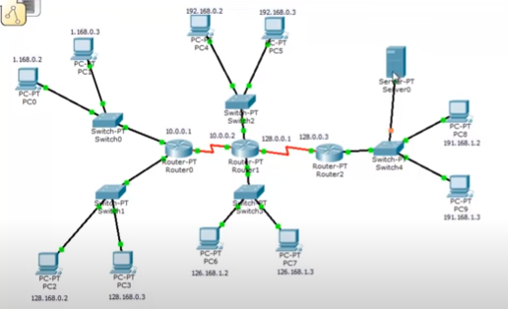

1. Fill the Configuration details of each device in the table given below.

|  |  |  |
| --- | --- | --- |
| Devices | Interface | IP address |
| Router 0 |  |  |
|  |  |
| Router1 |  |  |
|  |  |
| Router 2 |  |  |
|  |  |
| Router 3 |  |  |
|  |  |
| PC1 |  |  |
| PC2 |  |  |
| PC3 |  |  |
| PC4 |  |  |
| PC5 |  |  |
| PC6 |  |  |
| PC7 |  |  |
| PC8 |  |  |
| Server1 |  |  |

1. Configure Routing Information Protocol (RIP) routing in CISCO packet tracer for the constructed topology in (a) using the IP details assigned in (b) and show the successful packet transmission between the any two PCs(print the details using “show ip route” command)